**DATABASE MANAGEMENT SYSTEM ASSIGNMENT**

* **28th May 2025**
* **Abhik Chakraborty (**[**Abhik.Chakraborty@bounteous.com**](mailto:Abhik.Chakraborty@bounteous.com)**)**

1. **Create the tables below in the database. Use foreign keys and primary keys as required.**
   1. **Create a table called as student with the following columns student_id, first_name, last_name ,birthdate , department_id ,address_id .**
   2. **Create Address table with following columns address_id , street_address, city, State, postal_code**
   3. **Create department table department_id, department name. Make sure you are using the right data type against all the columns.**

Solution:

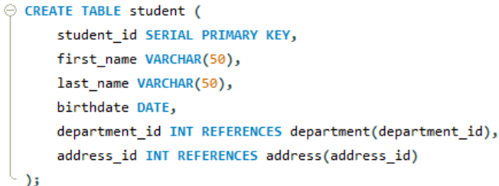

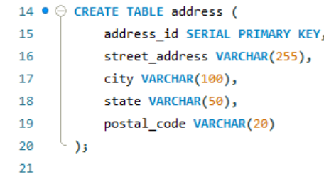

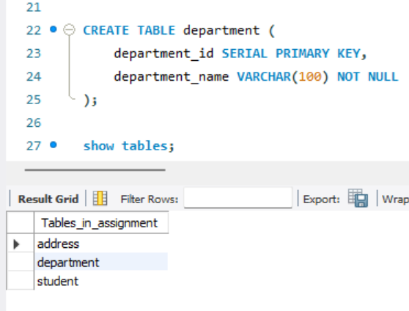

1. **Use Sample data from** [**sampledata.txt**](https://hs2solutions-my.sharepoint.com/:t:/g/personal/iqbal_sarkar_bounteous_com/ET8VdCEdjTJNoaWCrFPFxfwBq9bpLp9HkT7ycwnltym8qA?e=xTKw8M) **to insert data into the database.**

Answer:  
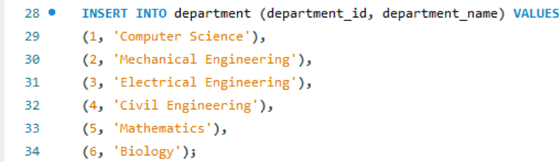

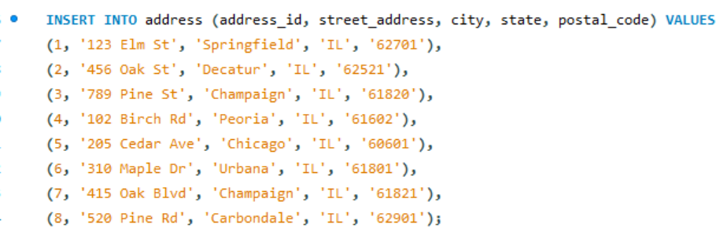

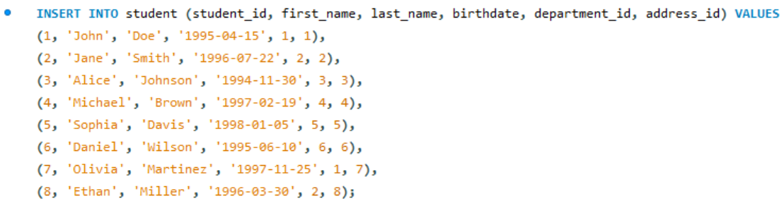

1. **Write a query to find the total number of students.**

Answer:

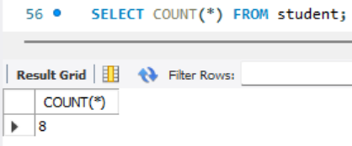

1. **Write a query to find which department john belongs to.**

Answer:

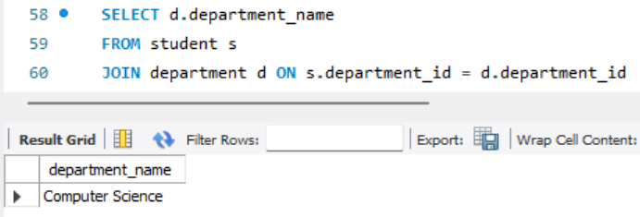

John belong to Computer Science department.

1. **List All Departments with Their Number of Students (Including Departments with No Students)**

Answer:  
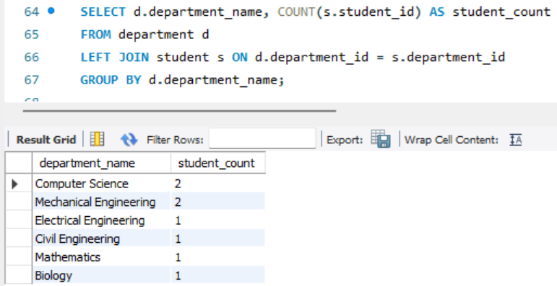

1. **Select all students with their department and address.**

Answer:

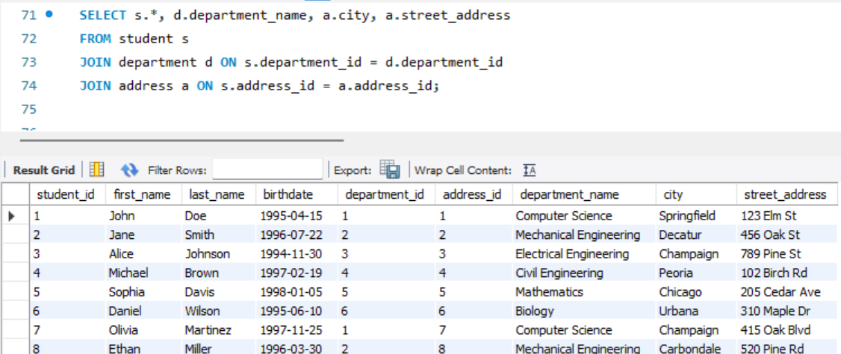

1. **Find all students who are in the 'Computer Science' department**

Answer:

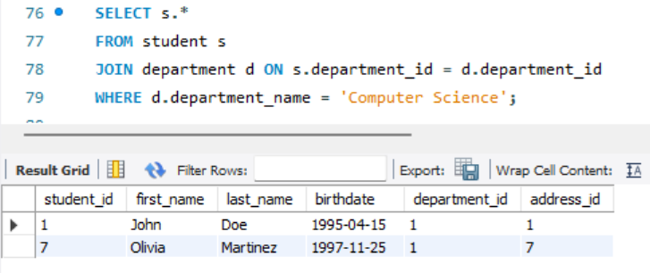

1. **Update Jane’s city name to New York.**

Answer:   
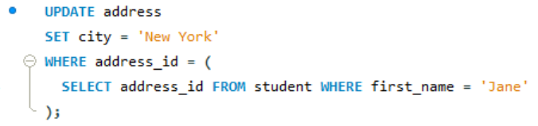

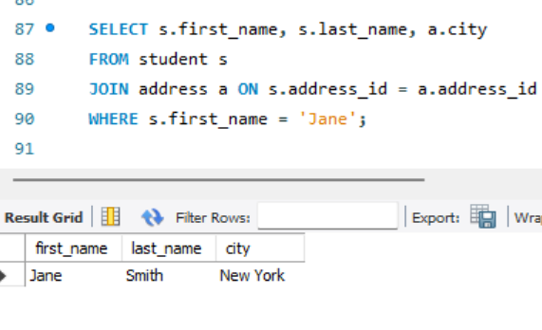

1. **Delete a student from the student table.**

Answer:

Before deleting:  
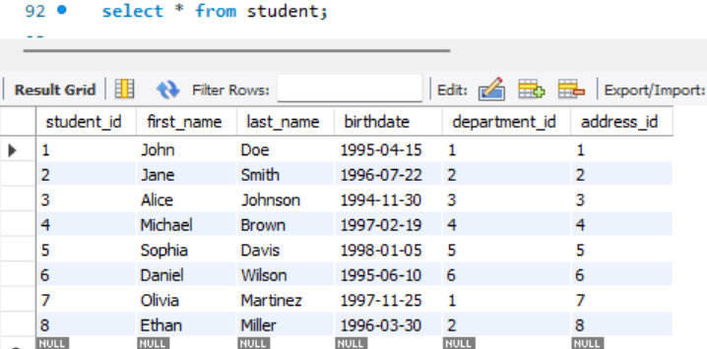

After deleting:

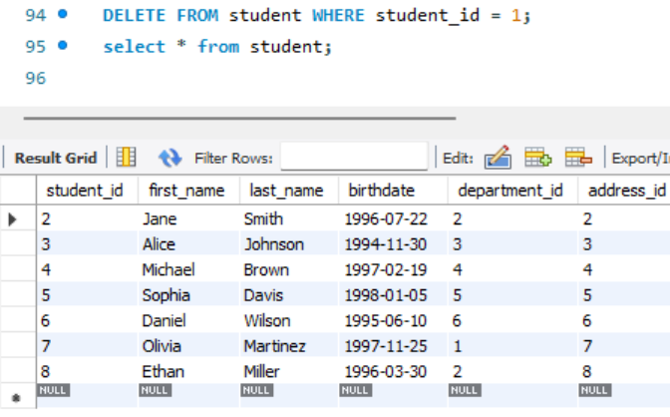

John with student_id = 1 is deleted.

1. **Select all students with their department and address in New York.**

Answer:

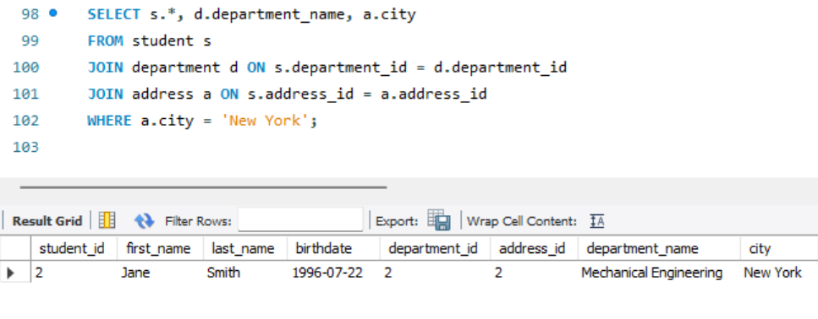

1. **Count how many students are in each department**

Answer:

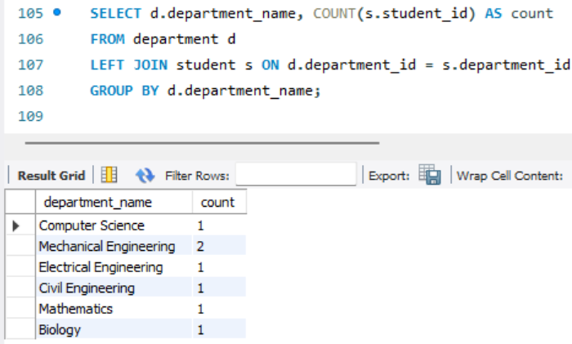

1. **Find students who live in 'Springfield'**

Answer:

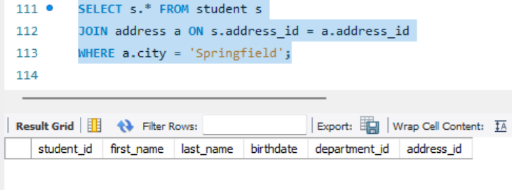

There is no student from city = Springfield.

1. **Select students whose birthday falls in February**

Answer:   
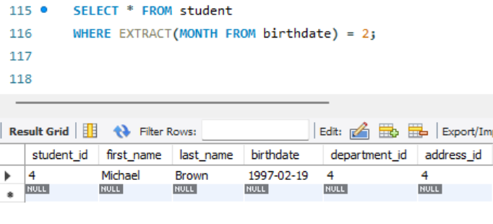

1. **Get the department and address details for a specific student, example john**

Answer:

Since John is deleted form database because of earlier query, took the example of Jane  
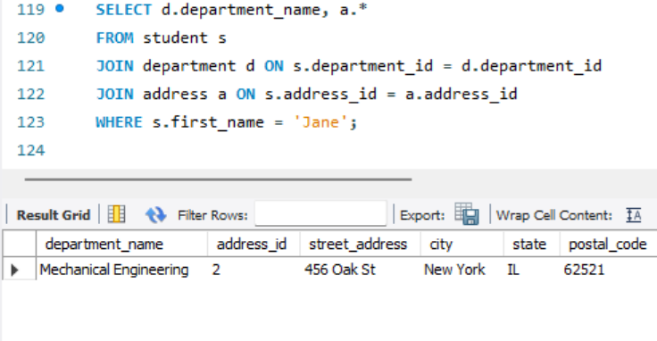

1. **Find all students who are born within 1995 to 1998**

Answer:

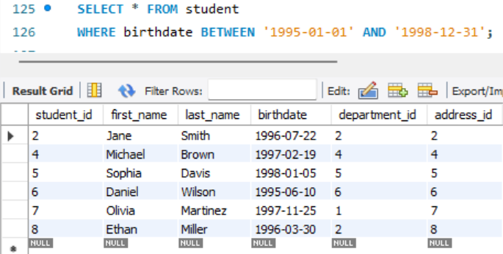

1. **List all students and their corresponding department names, sorted by department**

Answer:

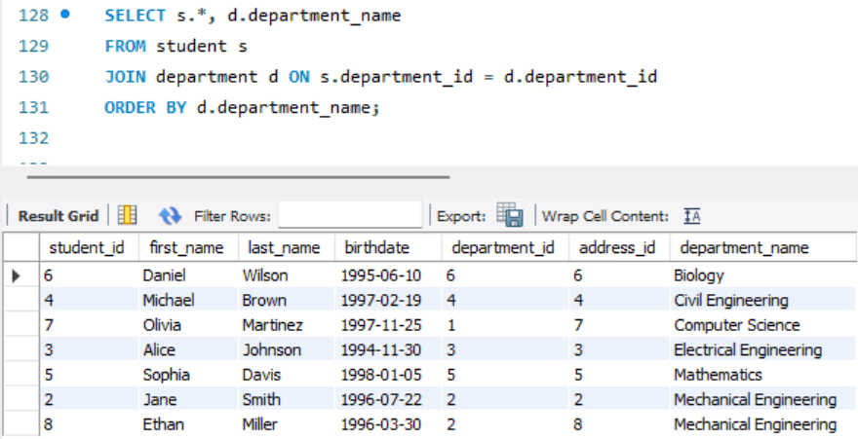

1. **Find the number of students in each department who are living in 'Champaign'**

Answer:

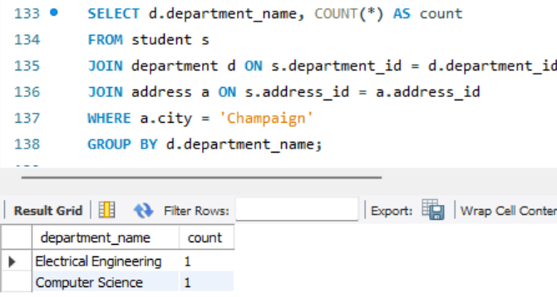

1. **Retrieve the names of students who live on 'Pine' street**

Answer:

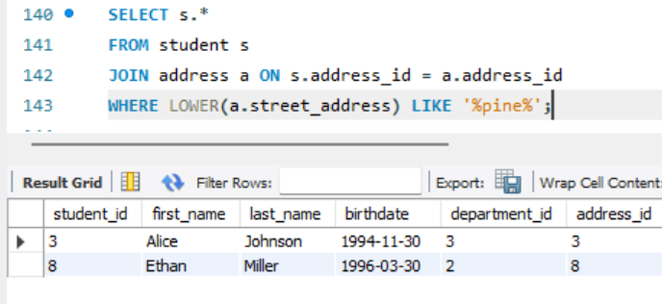

1. **Update the department of a student with student_id = 6 to 'Mechanical Engineering'**

Answer:

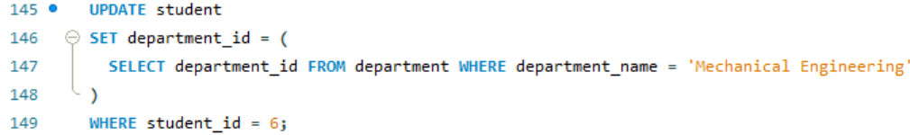

Query to check:  
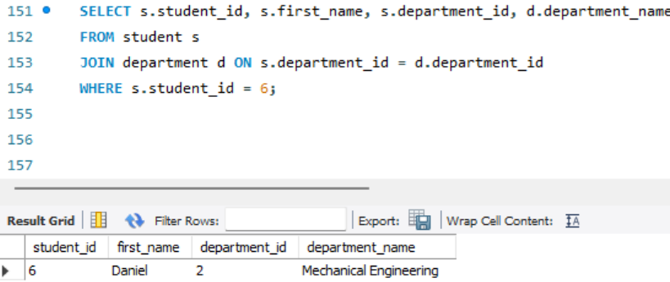

1. **Find the student(s) who live in the city 'Chicago' and are in the 'Mathematics' department**

Answer:

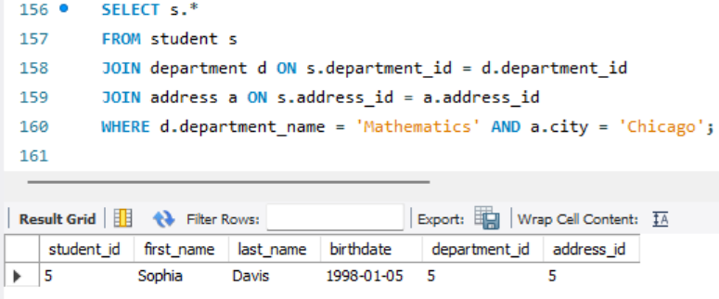

1. **List all students who have an address in 'Urbana' or 'Peoria'**

Answer:

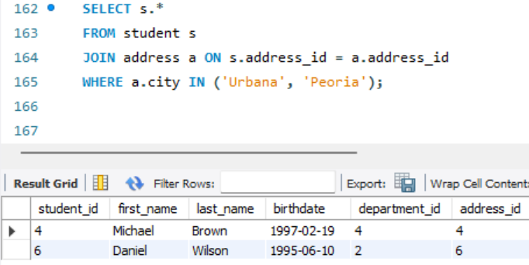

1. **Find the student with the highest student_id**

Answer:

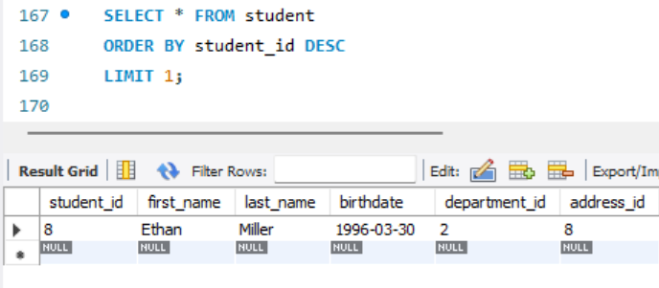

1. **Find all students who are not in the 'Computer Science' department**

Answer:  
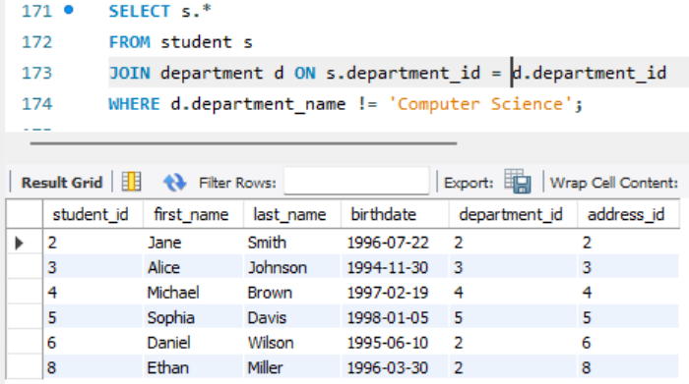

1. **Count the total number of addresses in the 'Champaign' city**

Answer:

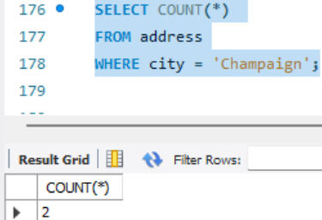

1. **Find the name of the student who lives at '520 Pine Rd'**

Answer:

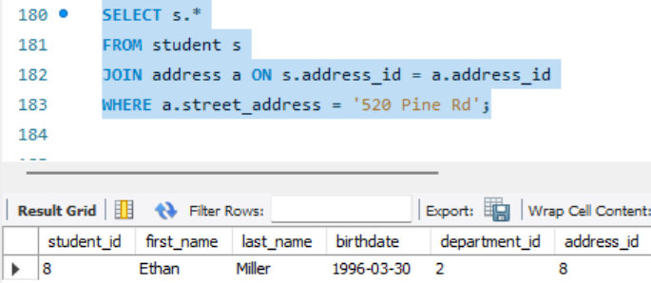

1. **Get the average age of students in the 'Electrical Engineering’ department**

Answer:

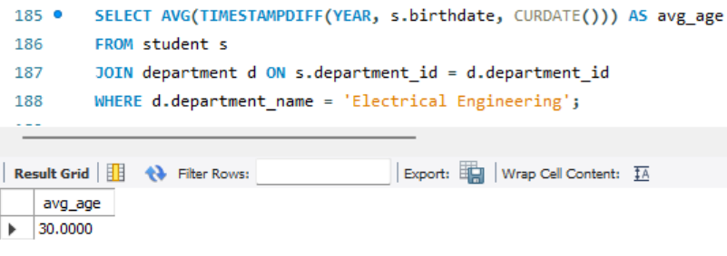

1. **List the students, their department, and the city where they live, but only for those in departments starting with 'M'**

Answer:

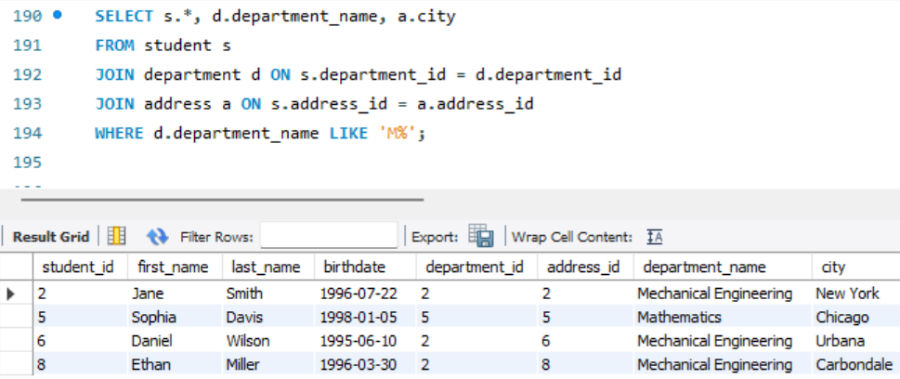

1. **Delete a student from the 'Mechanical Engineering' department**

Answer:  
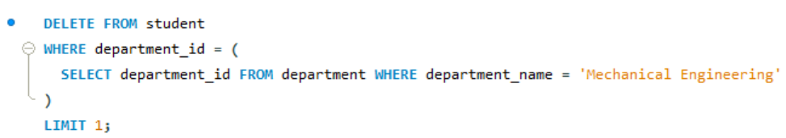

Verification Query:  
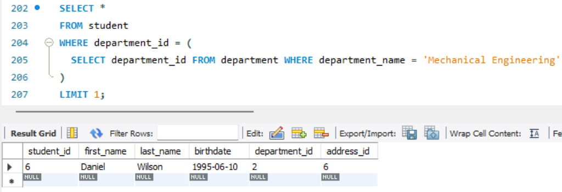

**Download** [**order.sql**](https://hs2solutions-my.sharepoint.com/:u:/g/personal/iqbal_sarkar_bounteous_com/ERszToxU3wJNo1HXV0zhiNgBMx8PQdMY207902wVY8Mnhg?e=qqdFSF)

**Open PG Admin and open query tool and select any database of your choice.**

**Click on “Open file” and select** [**order.sql**](https://hs2solutions-my.sharepoint.com/:u:/g/personal/iqbal_sarkar_bounteous_com/ERszToxU3wJNo1HXV0zhiNgBMx8PQdMY207902wVY8Mnhg?e=qqdFSF) **from your device and execute it.**

**Questions:**

1. **Retrieve All Orders with Their Customer Details and Current Status**

**Answer:**

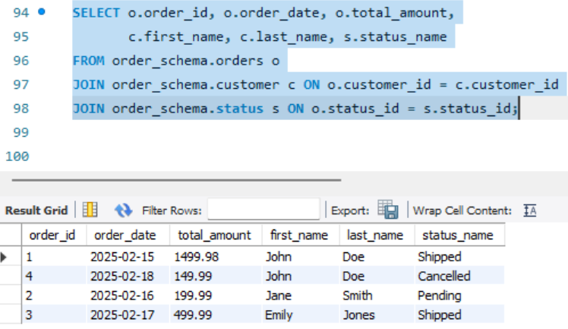

1. **Get the Total Value of Orders for a Given Customer in a Specific Time Period**

**Answer:**

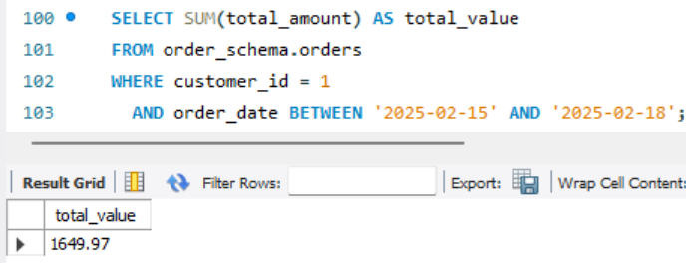

1. **Find the Most Expensive Order by Customer**

**Answer:**

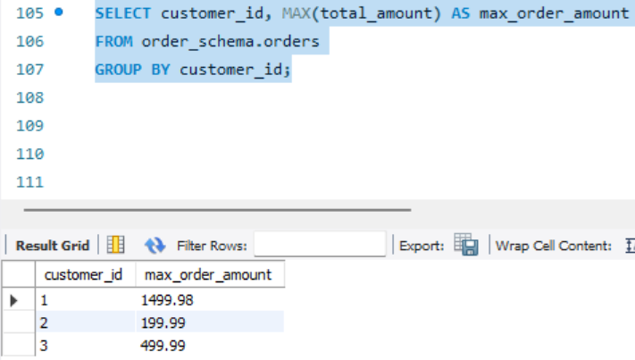

1. **Find the Total Revenue for Each Product Based on Orders**

**Answer:**

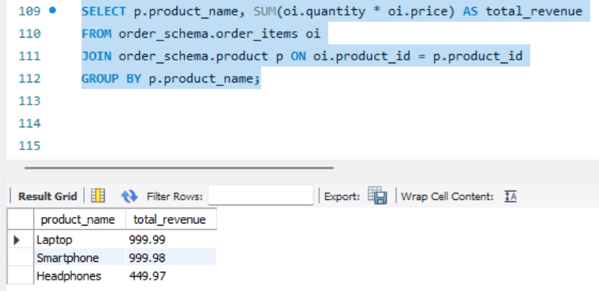

1. **Write a query to retrieve the order ID, customer ID, and the total amount of each order. If the total amount is null, display '0.00' instead.**

**Answer:**

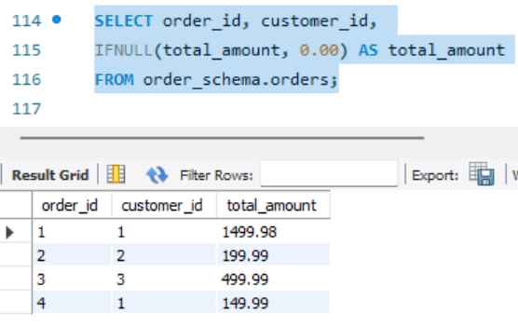

1. **Retrieve the Order History of a Specific Customer Along with Product Details**

**Answer:**

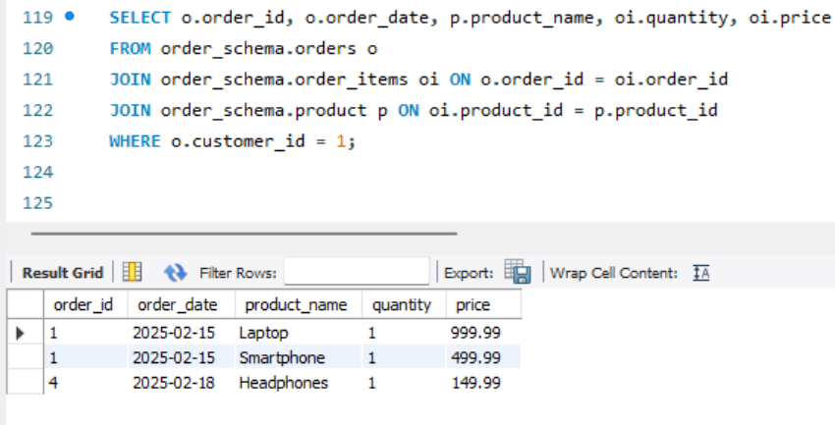

1. **Get the Average Order Value Per Customer in the Last 30 Days.**

**Answer:**

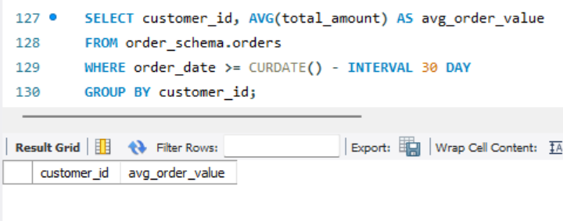

1. **Get the Top 5 Products with the Highest Number of Orders.**

**Answer:**

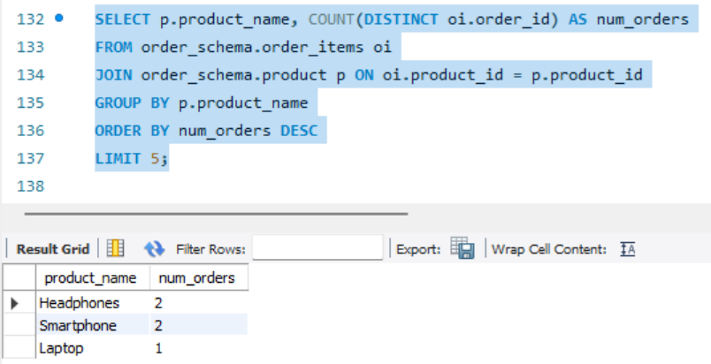

1. **Get the Customers Who Have Not Placed Any Orders in the Last 60 Days**

**Answer:**

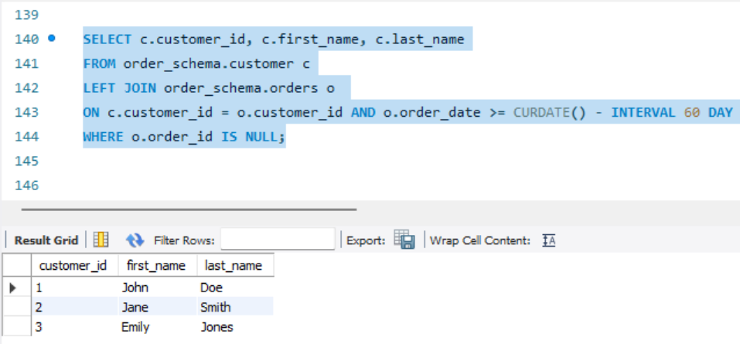

1. **List the Orders with Products Ordered More Than Once, Sorted by Order Date**

**Answer:**

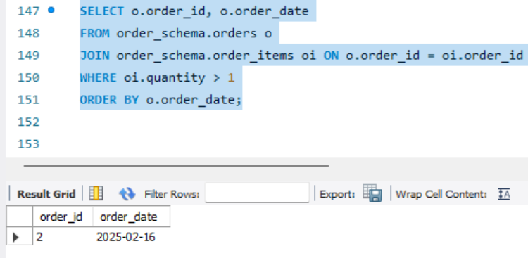

1. **Retrieve the Number of Orders and Total Revenue for Each Status**

**Answer:**

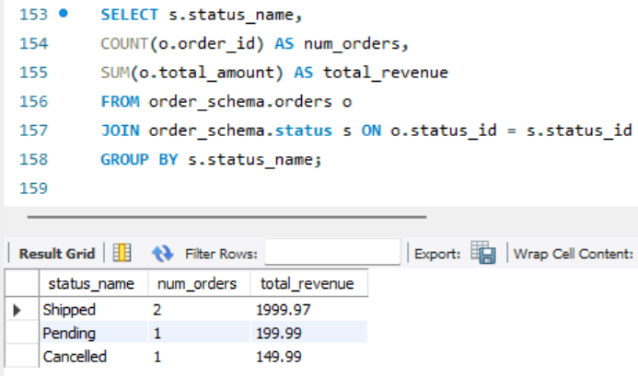

1. **Find Customers Who Have Ordered More Than a Specific Product (e.g., "Laptop")**

**Answer:**

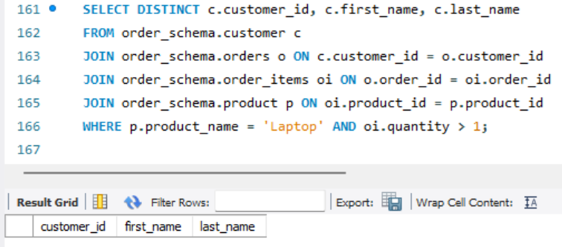

1. **Find the Products That Have Never Been Ordered**

**Answer:**

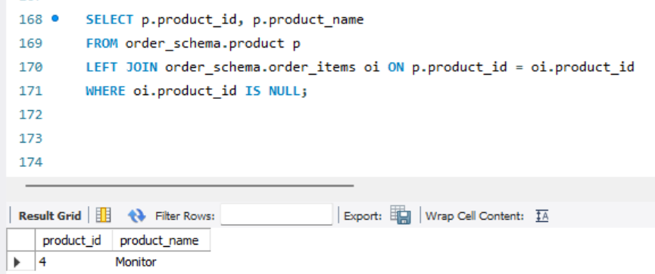

1. **Get the Total Quantity of Products Ordered in the Last 7 Days**

**Answer:**

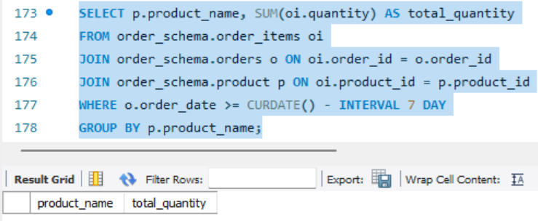

1. **Create a view named product_details that includes all columns from the product table.**

**Answer:**

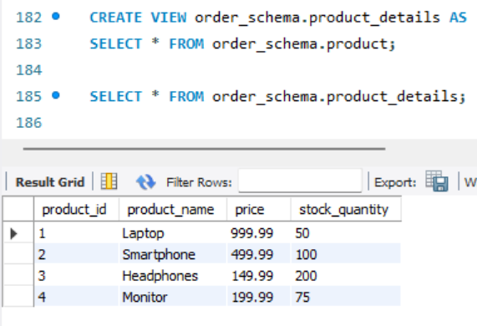

1. **Create a view named order_summary that includes the order_id, customer_id, order_date, total_amount, and status_name (from the status table) for each order.**

**Answer:**

